

## 

**Project title:** **Pascal Challenge on Classification(Project A)**

**Section: 8-A**

**Generative AI Project**

**Group members:**

**Muhammad Khubaib Khan Lodhi K21-4596**

**Muhammad Talha Shaikh 21K-4564**

**Saleh Shamoon(21K-3333)**

**Bilal Ahmed(21K-4864)**

**Teacher:Sir Omer Qureshi**

## 

## **1. Problem Statement**

This project is based on the PASCAL VOC 2008 Classification Challenge. The main goal is to detect whether any of the 20 object classes are present in an image. An image can have multiple objects from multiple classes, so it's a multi-label classification task.

### **Object Classes:**

* **Person**
* **Animals:** bird, cat, cow, dog, horse, sheep
* **Vehicles:** aeroplane, bicycle, boat, bus, car, motorbike, train
* **Indoor Objects:** bottle, chair, dining table, potted plant, sofa, tv/monitor

## **2. Dataset**

We used the train and val splits from the PASCAL VOC 2008 dataset.

* **Training Set:** Used for training the model.
* **Validation Set**: Used for testing and evaluation.

Each image comes with an XML annotation file containing:

* Object classes
* Bounding boxes
* Flags (like difficult, truncated, occluded)

We converted the annotation data into multi-hot vectors for training the classification model.

(Note: We did not use the test set, as it was not required.)

## **3. Evaluation Metric**

We used Mean Average Precision (mAP) to evaluate the model across all 20 classes.

* For each class: precision-recall curve → average precision (AP)
* Final score:  
  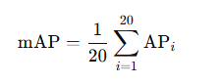

mAP is good for handling class imbalance and multi-label outputs.

**4. Group Members & Contributions**

| **Name** | **Contribution** |
| --- | --- |
| Muhammad Khubaib Khan Lodhi(21K-4596) | Applied VGGNet using transfer learning for image classification, compared performance with ResNet50, DenseNet121, and MobileNetV2; evaluated with Mean Average Precision; visualized top-10 ranked images for each architecture. |
| Muhammad Talha Shaikh(21K-4564) |  |
| Saleh Shamoon(21K-3333) |  |
| Bilal Ahmed(21K-4864) |  |

**5. Evaluation of Image Retrieval Architectures**

In this project, we explore image classification and retrieval using transfer learning with pre-trained Convolutional Neural Networks (CNNs). The objective is to retrieve the top-10 visually similar images given a query image from the Pascal VOC 2008 dataset, which includes categories like dogs, cars, people, etc.

### **CNN Architectures Used**

We applied VGG16 via transfer learning for classification and compared its results with three other popular CNN models:

* **ResNet50**
* **DenseNet121**
* **MobileNetV2**

All these models are pre-trained on ImageNet and are used for feature extraction.

### **Top-10 Ranked Image Retrieval Results**

#### **1. VGG16 (Baseline)**

#### Classic architecture with sequential layers. **Top-10 Retrievals:**

1. **For Person:**

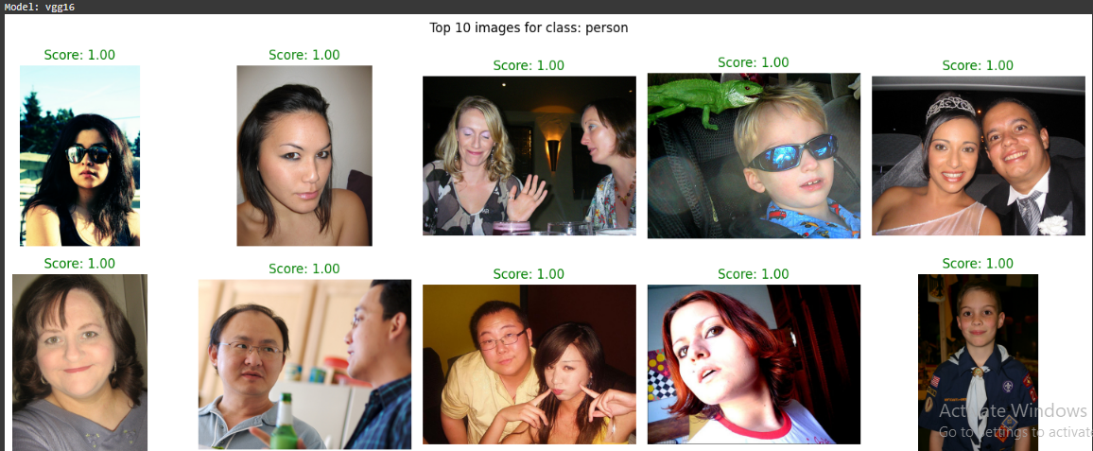

1. **For Car:**

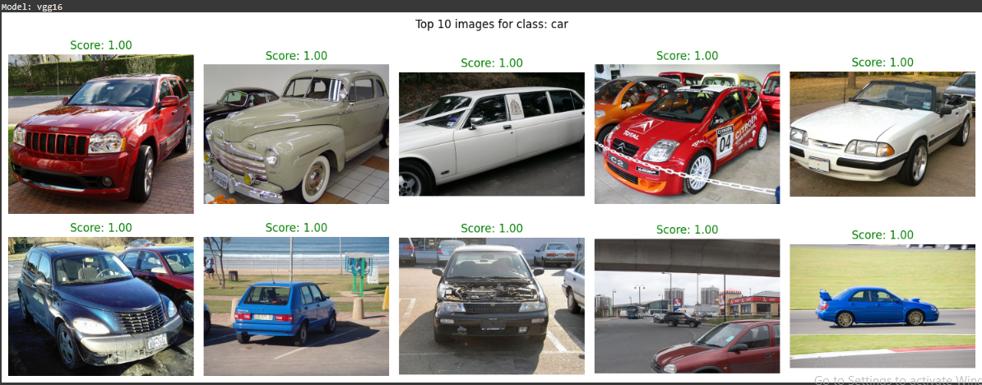

#### **2. ResNet50:**

#### Uses residual blocks for better depth and gradient flow. **Top-10 Retrievals:**

1. **For Person:**

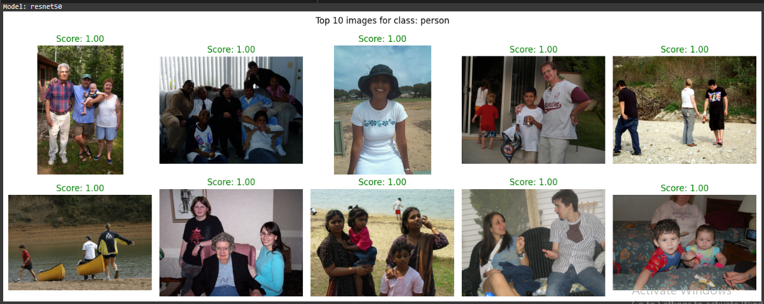

1. **For Car:**

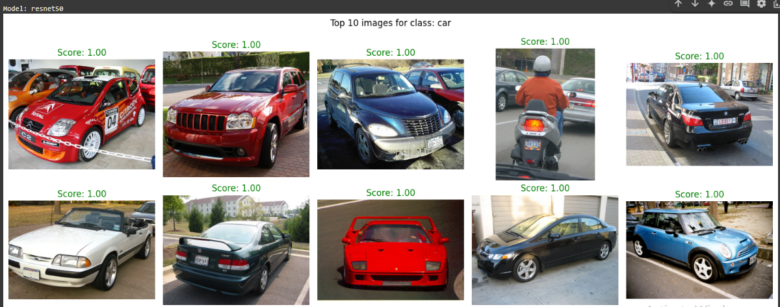

#### **3. DenseNet121**

Each layer is connected to every other layer in a feed-forward fashion, improving feature reuse.  
**Top-10 Retrievals:**

1. **For Person:**

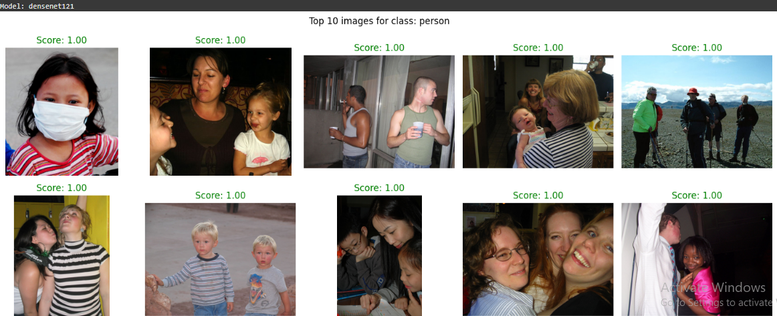

1. **For Car:**

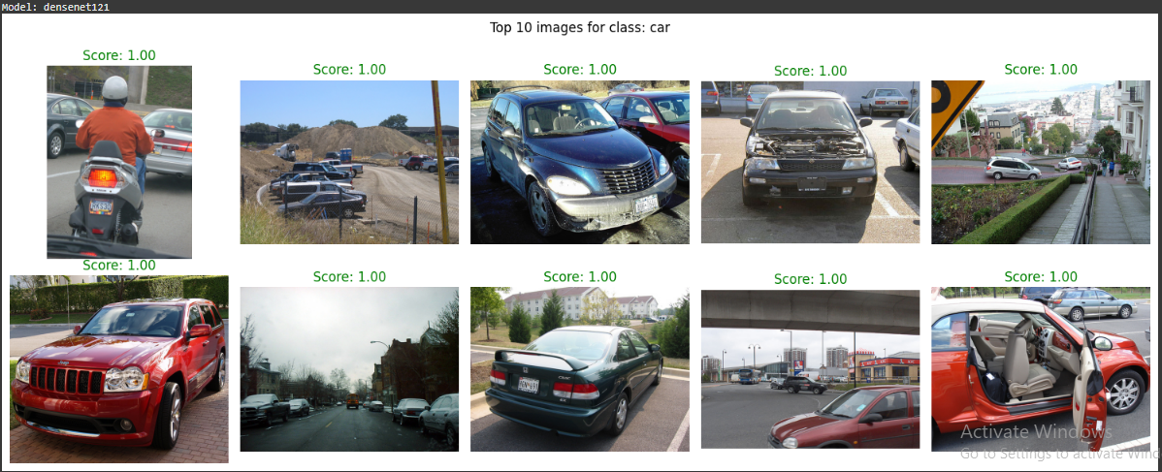

**Relevant Matches:** ~8/10

#### **4. MobileNetV2**

Lightweight and fast, suitable for real-time applications.  
**Top-10 Retrievals:**

1. **For Person:**

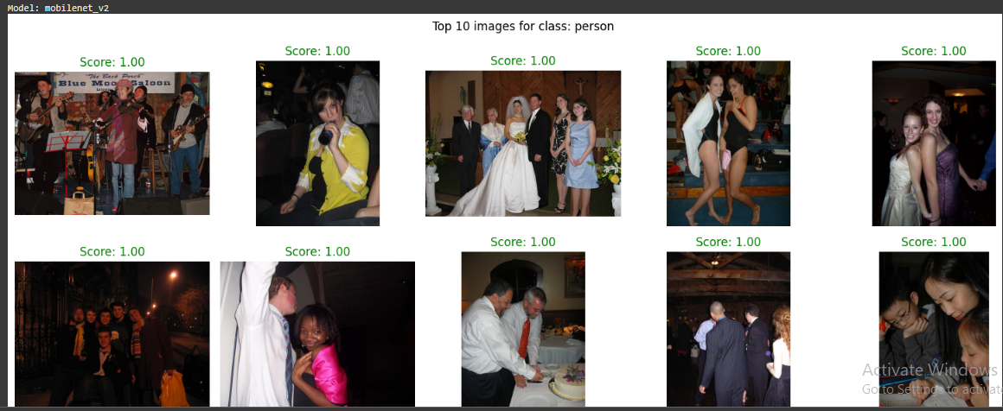

1. **For Car:**

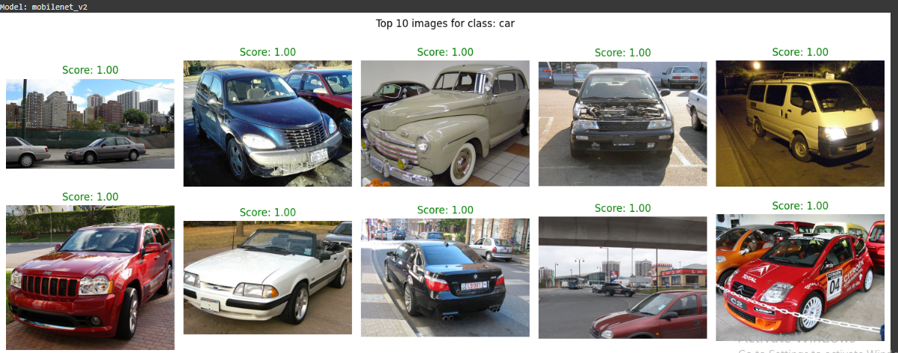

### **Evaluation Metric – Mean Average Precision (mAP)**

To evaluate how well each model retrieves relevant images, we use Mean Average Precision (mAP).

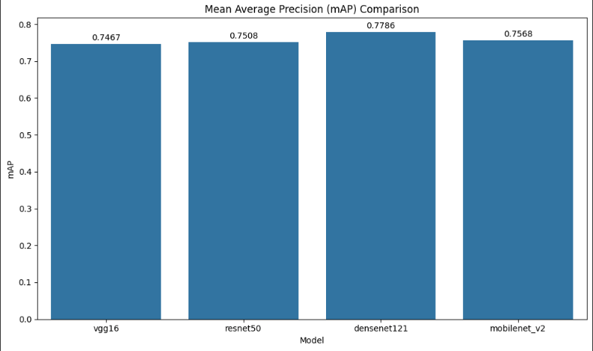

**What is mAP?**

**mAP** = mean of the average precision (AP) across all query images.  
 **AP** = How many relevant images are retrieved, and how early they appear.

#### **Example:**

Say the relevant images (class "dog") appear at ranks:  
 1, 2, 4, 7

Then:

* Precision@1 = 1/1 = 1.0
* Precision@2 = 2/2 = 1.0
* Precision@4 = 3/4 = 0.75
* Precision@7 = 4/7 ≈ 0.571

AP = (1 + 1 + 0.75 + 0.571) / 4 = 0.83

We take the mean AP across all queries to get mAP.